Project:

World Happiness Data in csv files

* Maps:
  + Happiness around the world
  + GDP
  + Family
  + Life Expectancy
  + Freedom
  + Government Corruption
  + Generosity
  + Dystopia Residual
* Analytics:
  + Which of these measurements correlate to happiness level?
* Other Data we can bring in:
  + Information on other countries relevant to the measurements

Data:

World Happiness Rankings

Time Range: 2015-2021

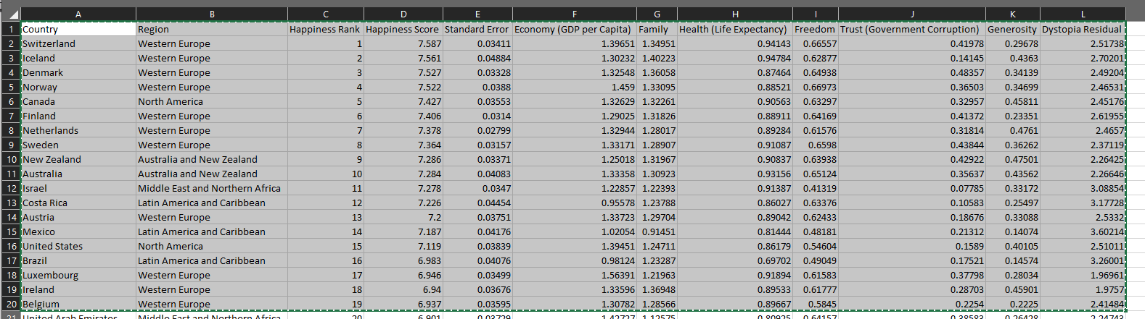

Tools:

How are we joining the data?

HTML

JS